**EXPERIMENT NO - 01**

**● AIM:**

Build responsive and interactive UIs using Tailwind CSS

**● THEORY:**

The **Soundora** project demonstrates how to build a **responsive, scalable, and visually engaging** user interface using **Tailwind CSS**, a utility-first CSS framework. This framework enables developers to create custom UI components quickly without writing traditional custom CSS.

**1. Introduction to Tailwind CSS**

Tailwind CSS is a low-level CSS framework that provides **utility classes** like text-center, bg-gray-100, p-4, and rounded-lg, which can be directly used in HTML markup. This allows for:

● **Rapid prototyping**

● **No need for context switching** between HTML and CSS files

● **Highly customizable components**

**2. Core Tailwind Concepts Applied in the Project**

**a. Utility Classes**

Utility classes are single-purpose classes that perform one function such as: ● **Text Styling**: text-center, text-4xl, font-bold, text-gray-900 ● **Spacing**: p-6, m-4, gap-4, px-4, py-2

● **Flex/Grid Layouts**: flex, items-center, justify-between, grid, grid-cols-3

● **Borders and Radius**: rounded-xl, border, shadow-md

● **Background Colors**: bg-indigo-700, bg-gray-100, hover:bg-blue-600

**b. Breakpoints (Responsive Design)**

Tailwind supports **mobile-first responsive design** using predefined breakpoints:

**Breakpoi nt**

**Prefi x**

**Min**

**Width**

sm sm: 640px md md: 768px

lg lg: 1024px

xl xl: 1280px

**Example:**

<div class="grid grid-cols-2 md:grid-cols-3 lg:grid-cols-5 gap-4">

This creates a:

● 2-column grid on mobile

● 3-column grid on medium screens

● 5-column grid on large screens

**c. Hover and Focus States**

Tailwind provides pseudo-class modifiers like hover: and focus:: <img class="hover:scale-105 transition" />

This enlarges the card image slightly on hover with smooth transition animation.

**3. UI Components and Structure**

**a. Header Component**

<header class="bg-indigo-700 text-white p-6 text-center shadow-md">

● Full-width colored banner

● Centered white title

● Drop shadow for elevation

**b. Grid of Cards (Genre Selection)**

<section class="grid grid-cols-2 md:grid-cols-3 lg:grid-cols-5 gap-6 p-6">

Each genre is shown as a **clickable card**:

● **Image**: Representing the genre (e.g., pop, jazz)

● **Label**: Genre name under the image

● **Hover Effect**: Zoom-in image using hover:scale-105

**c. Footer Component**

<footer class="text-center text-sm text-gray-500 py-6">

A minimalist copyright footer.

**d. Individual Genre Pages**

Each genre page includes:

Play controls at the top: **Play**, **Shuffle**, **Add to Library**

Song list as vertical cards

Each song has a name, artist, and icons

**● SOURCE CODE:**

**index.html:**

<!DOCTYPE html>

<html lang="en">

<head>

<meta charset="UTF-8" />

<meta name="viewport" content="width=device-width, initial-scale=1.0"/> <title>Soundora Music Genres</title>

<script src="https://cdn.tailwindcss.com"></script>

</head>

<body class="bg-gray-950 text-white font-sans">

<!-- Navbar -->

<nav class="flex items-center justify-between px-6 py-4 bg-black shadow-md"> <h1 class="text-2xl font-bold text-green-400">Soundora </h1> <ul class="flex space-x-6">

<li><a href="#" class="hover:text-green-400">Home</a></li> <li><a href="#" class="hover:text-green-400">Music</a></li> <li><a href="#" class="hover:text-green-400">Genres</a></li> </ul>

</nav>

<!-- Header -->

<section class="px-6 py-10 text-center">

<h2 class="text-4xl font-extrabold mb-4">Browse Music by Genre</h2> <p class="text-gray-400">Click on a genre to explore its full playlist</p> </section>

<!-- Genre Grid -->

<section class="grid sm:grid-cols-2 md:grid-cols-4 lg:grid-cols-5 gap-6 px-6 mb-12"> <a href="genre-pop.html" class="bg-pink-600 rounded-xl p-6 hover:scale-105 transition transform">

<h3 class="text-xl font-bold">Pop</h3>

<p class="text-sm">Top 40, Dance Pop</p>

</a>

<a href="genre-rock.html" class="bg-red-600 rounded-xl p-6 hover:scale-105 transition transform">

<h3 class="text-xl font-bold">Rock</h3>

<p class="text-sm">Classic, Alt Rock</p>

</a>

<a href="genre-hiphop.html" class="bg-yellow-600 rounded-xl p-6 hover:scale-105 transition transform">

<h3 class="text-xl font-bold">Hip Hop</h3>

<p class="text-sm">Rap, Trap, Urban</p>

</a>

<a href="genre-jazz.html" class="bg-blue-600 rounded-xl p-6 hover:scale-105 transition transform">

<h3 class="text-xl font-bold">Jazz</h3>

<p class="text-sm">Smooth, Classic Jazz</p>

</a>

<a href="genre-electronic.html" class="bg-green-600 rounded-xl p-6 hover:scale-105 transition transform">

<h3 class="text-xl font-bold">Electronic</h3>

<p class="text-sm">EDM, House, Trance</p>

</a>

<a href="genre-classical.html" class="bg-purple-700 rounded-xl p-6 hover:scale-105 transition transform">

<h3 class="text-xl font-bold">Classical</h3>

<p class="text-sm">Symphony, Instrumental</p>

</a>

<a href="genre-country.html" class="bg-yellow-800 rounded-xl p-6 hover:scale-105 transition transform">

<h3 class="text-xl font-bold">Country</h3>

<p class="text-sm">Folk, Acoustic</p>

</a>

<a href="genre-rnb.html" class="bg-pink-700 rounded-xl p-6 hover:scale-105 transition transform">

<h3 class="text-xl font-bold">R&B</h3>

<p class="text-sm">Soul, Smooth</p>

</a>

<a href="genre-reggae.html" class="bg-green-800 rounded-xl p-6 hover:scale-105 transition transform">

<h3 class="text-xl font-bold">Reggae</h3>

<p class="text-sm">Island Vibes</p>

</a>

<a href="genre-indie.html" class="bg-indigo-600 rounded-xl p-6 hover:scale-105 transition transform">

<h3 class="text-xl font-bold">Indie</h3>

<p class="text-sm">Alternative, Lo-fi</p>

</a>

</section>

<!-- Footer -->

<footer class="text-center text-gray-500 text-sm py-6 mt-12">

&copy; 2025 Soundora | Music Genre Explorer | Powered by Tailwind CSS </footer>

</body>

</html>

**classical.html**

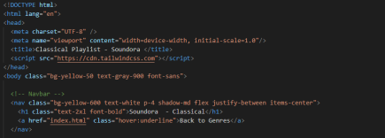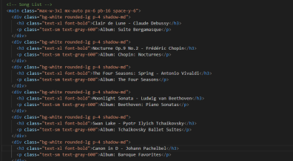

**country.html**

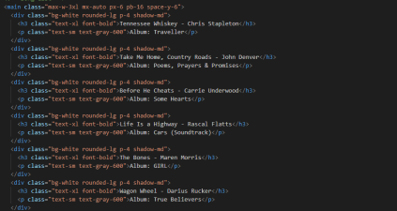

**electronic.html**

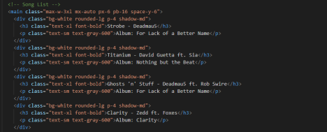**hiphop.html**

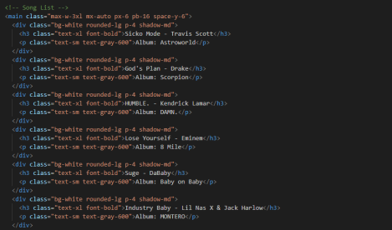**indie.html**

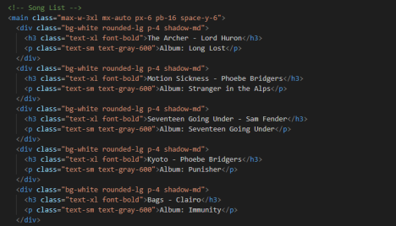**jazz.html**

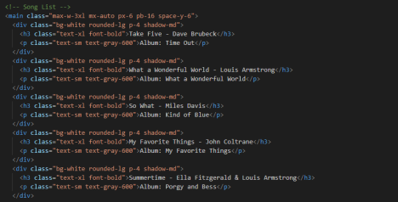**pop.html**

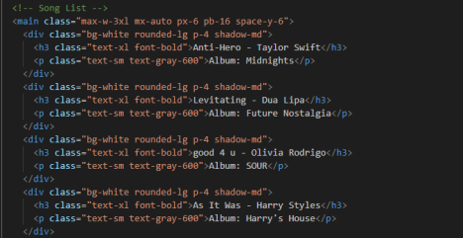**reggae.html**

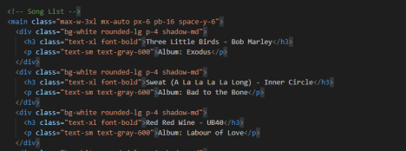**rnb.html**

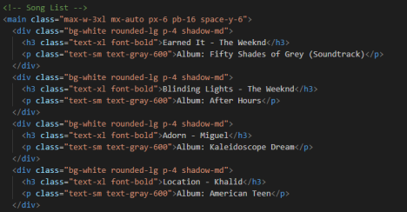**rock.html**

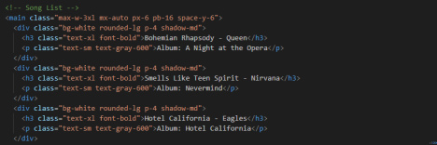**OUTPUT:**

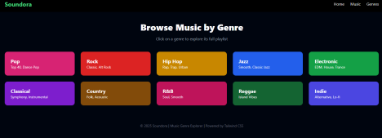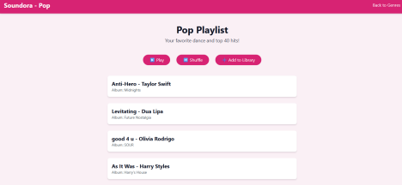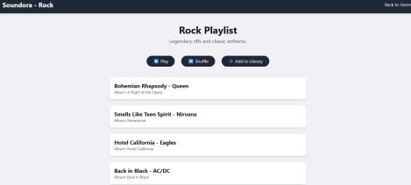

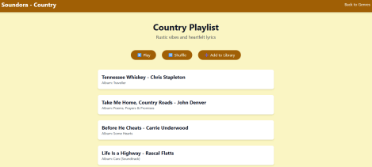

**CONCLUSION:**

Using Tailwind CSS, we successfully created a **modern, responsive, and interactive music UI** called **Soundora**, offering a smooth user experience. The project demonstrates how **utility-first CSS** can simplify styling, promote reusability, and deliver polished front-end applications for real-world scenarios like music platforms.